$(GAME_NAME)

Overview

$(GAME_NAME) is a two dimensional top-down competitive shooter inspired by competitive arena first-person shooters such as Quake, Unreal Tournament, and Team Fortress 2.
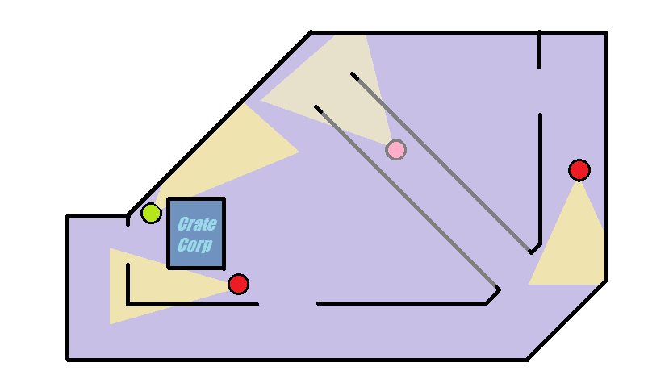
Game-play takes place in levels varying in size from small to large, known as maps. In general, maps will be designed for one or several game modes and will not be playable on game modes for which it was not designed, although the map system allows for maps which support all game modes.

Each player has a range which determines how much of the map is visible at once, and a view angle which determines how wide their line of sight is. Other entities, such as weapons, ammo, and other players, are only visible if they are in the player's line of sight.

In the mock-up drawing shown above, players are shown with their respective lines of sight, indicating the direction in which they are looking. Not shown in the drawing, lines of sight are obscured by parts of the level such as walls and the Crate Corp. crate. The grey faded area indicates a lower floor of the map. If players are on the correct side of the passage entrance, some of it will be visible (fading out further away) and they will be able to go through it. Otherwise, it will not be visible and they will just walk over it like normal floor.

Game Modes

A.

